Renewing the State of Michigan Controlled Substance License

Register for an account

If this is the first time you’re using the State of Michigan (SOM) MiPlus system, you will have to register for a new account.

Link: Instructions from the SOM
Important reminders:
- Register as an individual

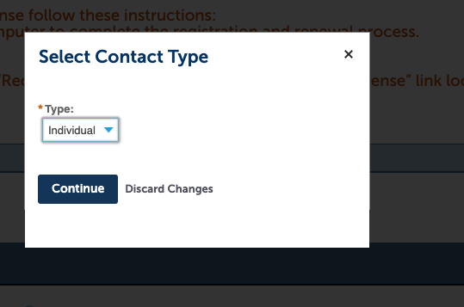

- You can now enter your mailing address (as separate from your drug storage address).

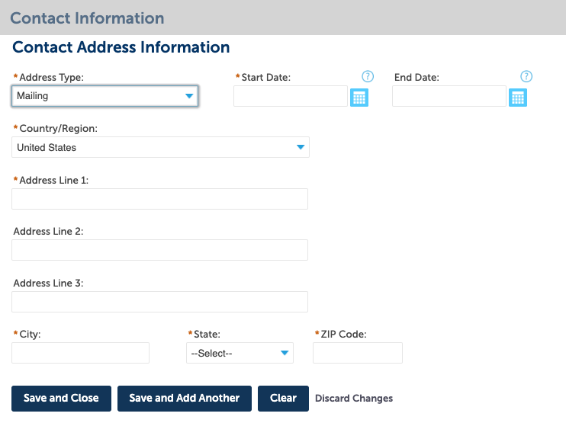

Renew your license

If you entered your information correctly when registering your account, ‘click here to renew license’ will appear next to your license number.

Link: Generic instructions from the SOM
Important reminders:

- When going through the renewal steps, you will come to the ‘Drug Storage Location’ page. It will be blank and you will be unable to enter any information. Just click ‘continue’ and go to the payment page.

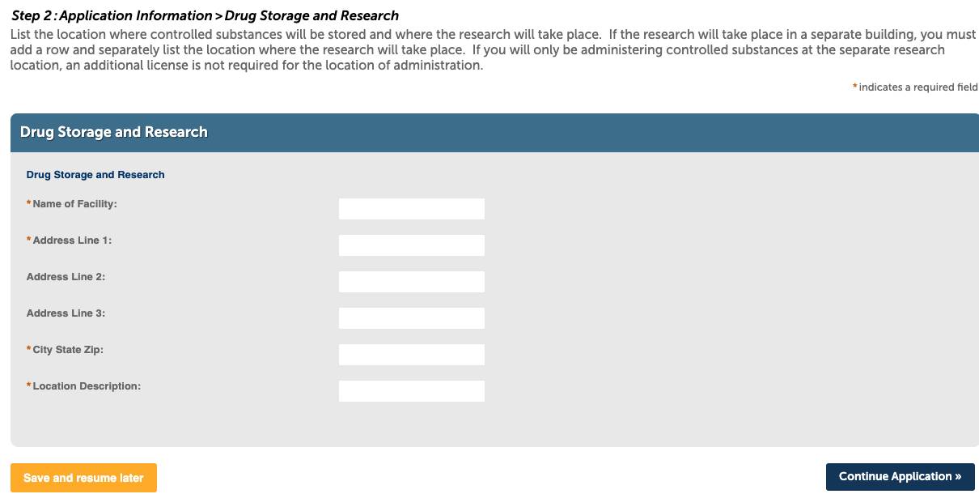

- Your license will renew immediately and you will have the option to print a copy. The address will no longer be listed on the main page of the license. Keep the top page, as this is the only portion of the license where the storage address is listed.

Contact the CS Monitors if you have questions!
CS-monitors@med.umich.edu

